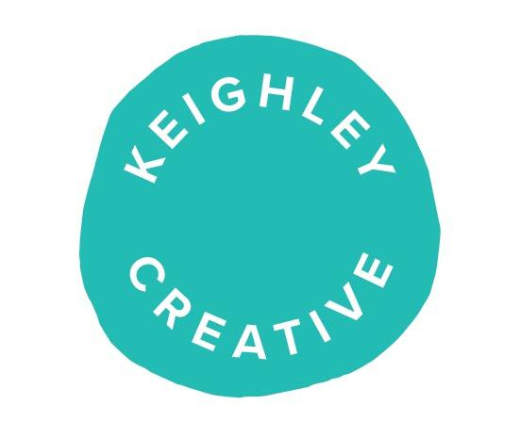
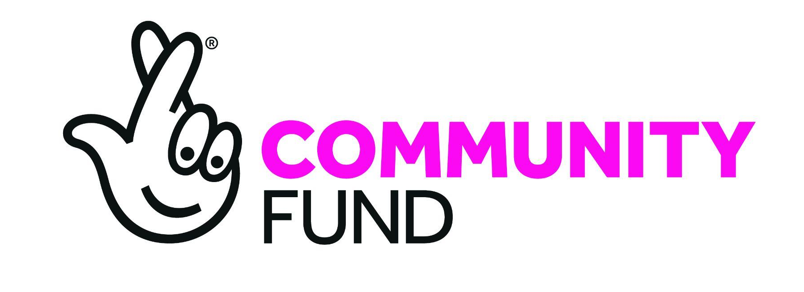

Cultural Heritage and Diversity Lead

Employer: Keighley Creative (KC) Charitable Incorporated Organisation
Contract Length: Initial eight-month contract
Location: Keighley Creative, Old Sunwin House Building, Cavendish Retail Park, Keighley BD21 3RB
Salary: £27k per annum pro-rata
Hours: 15 hrs per week
Directly Responsible to: Keighley Creative Managing Director
Funded by: National Lottery Awards for All

Purpose of role:
To work with Keighley’s diverse communities, focussing on and finding out about the rich cultural heritage that makes up our town.
Keighley is home to long established communities of South Asian heritage (primarily of Pakistani and Bangladeshi descent); Polish; Italian; Ukrainian; Caribbean; Slovakian; Lithuanian; and relatively new communities from other parts of the world including asylum seekers and refugees.
This role will identify what creative and cultural activities are already underway, set up new arts and creative opportunities that have been requested by the community, and ensure that Keighley Creative’s current and future work is representative and culturally relevant for Keighley.
This role will be part of the wider team within Keighley Creative, delivering the overall mission and vision of the charity and building on existing links and engagement work the Charity has already undertaken during the last three years.

JOB DESCRIPTION

Outreach and Engagement
- To lead the Charity's work establishing links with Keighley’s diverse heritage-linked community groups, organisations and faith networks.
- To identify creative opportunities to co-create/deliver practical arts and cultural workshops and events with specific communities.
- To work with the team to ensure Keighley Creative’s work is representative and culturally relevant for Keighley, and that all communities can input into the charity’s work regarding our new Town’s Fund grant aided building refurbishment, both in terms of consultation on its design and accessibility, and in relation to the activities and events that will be held in the building and wider town in the future.
- To work with the Keighley Creative team to ensure that artists and creatives from diverse backgrounds are aware of, and can access, the Keighley Creative studio programme, network and employment opportunities.
- To work with the festival team to ensure that the town’s annual Arts & Film Festival (KAFF) has a varied and diverse programme of activities and events that are accessible and hold interest for all the town's residents.
- To work with Keighley Creative to ensure that The Unit, which will be based with Keighley Creative from September 2022, has a varied and diverse programme of activities and events that are accessible for all the town's film-makers of the future.
- To identify people of diverse heritage who may be interested in joining the Trustee Board of Keighley Creative.

Administration
- Managing and responding to enquiries from diverse heritage organisations and individuals to increase their participation in arts and cultural activities in Keighley.
- Updating the Keighley Creative database to incorporate new creatives, audiences and organisations identified during this outreach and engagement work.
- Ensuring individuals, community groups and organisations are described in monitoring and evaluation in preferred ways that reflects their heritage and culture.
- Evaluating and measuring the impact of this work, for Keighley Creative and National Lottery Awards for All, so it can develop into meaningful future programmes, conversations and lasting partnerships.

General
- Ensure that all activities and interactions operate within the key values and ethos of Keighley Creative (see appendix at end of this document)
- Actively engaging with Keighley Creative’s vision and policies, including equal opportunities and diversity, health and safety, data protection, safeguarding and impact evaluation and monitoring.
- Any other duties that are commensurate with the post.

Person Specification

- Sensitive and enthusiastic, experienced in working with a wide range of people and community groups.
- Excellent listening skills, and ability to help realise ideas.
- Able to operate independently within a supportive team and Charity Trustee environment.
- Bi-lingual or multi-lingual in one (or more) of the main community languages spoken in our locality, such as Panjabi or Urdu would be an advantage.
- Experience of delivering creative/cultural work with communities, either locally or elsewhere, that are from similar backgrounds to at least one of Keighley’s diverse heritage communities.
- Good standard of written and spoken English.
- Good computer literacy skills (can use email, simple spreadsheets, and text editing software).
- Able to commit to occasional evening and weekend working for which time-off in lieu will be given.

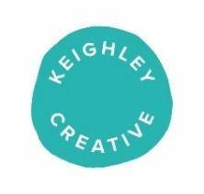
Purpose, Mission and Vision

Our Mission is
Develop an artist-led creative community hub in Keighley town centre, and outreach programmes across the surrounding area that give everyone in Keighley the opportunity to share, express and realise their creative and cultural aspirations.

Our purpose is
Improve the lives and opportunities of everyone in Keighley, changing stereotypes and prejudices by making our town a more creative, more attractive and thriving place to live, work and socialise.

Our vision is
Keighley is known as a creative town. The people of Keighley feel able to express their own creativity day to day and are confident and proud of the place where they live. More have embarked on training and careers in the creative industries. Our hub will be thriving, delivering year-round activities, exhibitions and events made for, with and by the people of Keighley.

At its heart is a community of professional artists, many based in the building, who are inspirational and aspirational role-models. Keighley has a thriving community of artists, creatives, and arts organisations, working in partnership across the district and region and providing opportunity to access and enjoy all aspects of cultural activity.

Alongside our own hub, Keighley’s streets and buildings reflect the importance and value that is placed on culture, heritage and creativity here with imaginative and surprising interventions from street furniture to wall paintings, signage and lighting, celebrated and refreshed each year through its famous festival.

Keighley has played a central role in Bradford UK city of culture 2025 and is recognised nationally as a cultural destination to visit and as a place for artists and creatives to live and work.

Our values are
- Open to everyone: sharing our space with trust and equity
- Excellence: we are committed equally to excellence in artistic process and outcome
- Creativity: making art and creativity accessible
- Listening: Listening to individuals, groups, and community with empathy
- Learning: Learning is at the heart of all our programmes
- Regeneration: Bringing people back into Keighley through arts engagement
- Support: Enabling new and existing studio holders and other local arts projects to join in with creative activities
- Inspiration: Motivate and inspire the community to join in with creative activities
- Representative: We are connected and rooted in our people and our place
- Collaboration: Working in partnership is the only way to realise our purpose
- Enjoyment: Bringing fun, entertainment and pleasure to people of all ages, interests and backgrounds

We will achieve our mission by
- Supporting artists, exhibiting and championing creativity, playing and learning, celebrating and sharing
- Listening to and working together in partnerships with the people, businesses and representatives of Keighley
- Devising and delivering our programme activity with and for the people of Keighley, ensuring that our activities are relevant and representative
- Celebrating the creative potential in everyone, providing creative activity and opportunity that is excellent - and fun – and valuing the creative process and endeavour as much as artistic outcome
- Playing an active civic role, providing leadership in the culture and creative sector here and supporting others, in partnerships with BMDC, KTC and ACE, to realise their full potential too.
- Giving particular opportunity to the most underrepresented and least engaged people of Keighley. This will be made manifest in our programme which will celebrate all of contemporary Keighley, making creative, international links to the places and cultures that Keighley connects to through our people and businesses. It will also be reflected in our pricing, the look and feel of our spaces and projects, the membership of our board and advisory groups and our staffing and recruitment
- Putting Keighley on the map – through our festival and day-in-day-out - as a town with exciting arts, culture, and creative things to get involved in and experience as a local and to attract visitors, businesses and inward investment to Keighley
- Foregrounding and developing our artistic expertise in visual arts and creative practices as wellbeing tools, celebrating all art forms through our festival and signposting to others with expertise in other creative forms
- Understanding and being able to measure and describe the impact we have and the difference we make through our work

